- TASK - Design a normalized database schema (3NF) with ERD showing all relationships between 8 tables.

Normalized database schema (3NF)

Table | Primary Key | Foreign Key Relationships | Notes
customers | customer_id | Referenced by orders.customer_id | 1-to-many (one customer → many orders)
orders | order_id | FK → customers.customer_id | Central table linking payments, reviews, items
order_items | (order_id, order_item_id) | FK → orders.order_id, products.product_id, sellers.seller_id | Composite PK ensures uniqueness per item
products | product_id | Referenced by order_items.product_id | Linked to categories (if added later)
sellers | seller_id | Referenced by order_items.seller_id | 1-to-many (one seller → many items)
order_payments | (order_id, payment_sequential) | FK → orders.order_id | Composite PK supports multiple payments per order
order_reviews | review_id | FK → orders.order_id | Each review belongs to one order
geolocation | geolocation_id | Referenced by customer/seller ZIP codes (conceptually) | Surrogate PK added for normalization

ERD Diagram
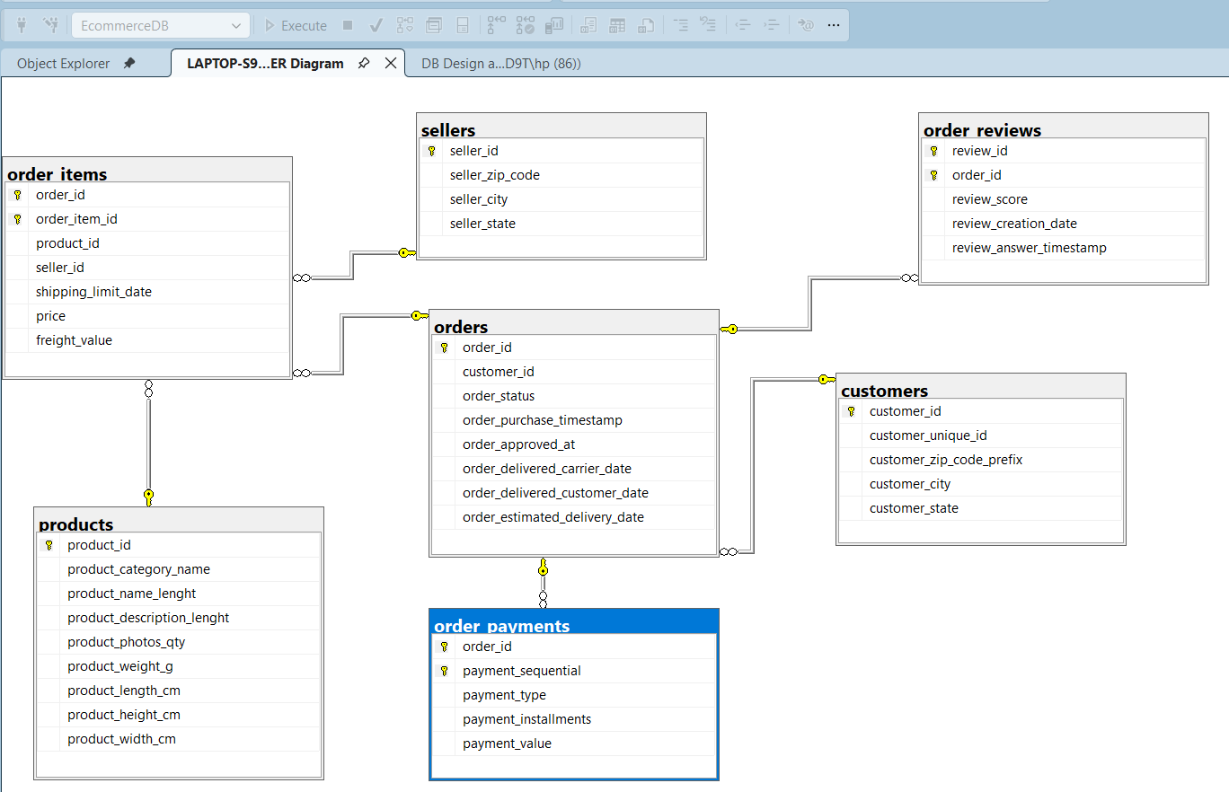

- TASK - Identify and document 10+ data quality issues in the raw CSV files.

- Missing values: Several columns such as product_category_name, review_comment_title, and review_comment_message contain NULL or blank entries, leading to incomplete data.
- Duplicate records: Some tables like customers and sellers have repeated rows or identical IDs, which can distort counts and violate primary key constraints.
- Incorrect data types: ZIP codes were imported as integers instead of text, causing loss of leading zeros and mismatched joins.
- Invalid foreign key references: Certain order_items.product_id and order_reviews.order_id values do not exist in their parent tables, breaking referential integrity.
- Spelling inconsistencies: Category names such as beleza_saude and beleza_saúde differ slightly, creating multiple entries for the same category.
- Outliers in numeric fields: Columns like price, freight_value, and product_weight_g contain extreme or unrealistic values (e.g., zero or excessively high).
- Date format inconsistency: Timestamps appear in mixed formats (YYYY-MM-DD and DD/MM/YYYY), causing sorting and conversion errors.
- Mixed case and extra spaces: City and state names vary in capitalization or spacing (e.g., Sao Paulo vs. sao paulo), leading to duplicate entries.
- Encoding issues: Non-ASCII characters (é, ç, ã) in Portuguese text cause import errors or truncation when not handled with UTF-8 or NVARCHAR.
- Unrealistic delivery dates: Some orders show delivery dates earlier than purchase dates, indicating logical inconsistencies.
- Blank strings instead of NULLs: Empty text fields are stored as '' rather than proper NULLs, misleading completeness checks.
- Non-unique identifiers: Columns like customer_unique_id repeat across rows, preventing them from being used as reliable primary keys.

5. Task – Create a comprehensive data dictionary documenting each table, column, data type, and business meaning.

EcommerceDB Data Dictionary
This document provides a comprehensive description of each table,
column, data type, and business meaning in the normalized (3NF) schema.

Customers Table
- customer_id (VARCHAR(50), PK): Unique identifier for each customer.
- customer_unique_id (VARCHAR(50)): Business-level identifier; may repeat if the same customer places multiple orders.
- customer_zip_code_prefix (VARCHAR(10)): Postal code prefix of the customer’s address.
- customer_city (NVARCHAR(100)): City where the customer resides.
- customer_state (NVARCHAR(50)): State where the customer resides.

Orders Table
- order_id (VARCHAR(50), PK): Unique identifier for each order.
- customer_id (VARCHAR(50), FK): References customers.customer_id.
- order_status (NVARCHAR(50)): Current status of the order (e.g., delivered, shipped, canceled).
- order_purchase_timestamp (DATETIME): Date and time when the order was placed.
- order_approved_at (DATETIME): Date and time when the order was approved.
- order_delivered_carrier_date (DATETIME): Date when the order was handed to the carrier.
- order_delivered_customer_date (DATETIME): Date when the order was delivered to the customer.
- order_estimated_delivery_date (DATETIME): Estimated delivery date provided at purchase.

Products Table
- product_id (VARCHAR(50), PK): Unique identifier for each product.
- product_category_name (NVARCHAR(100)): Category name of the product.
- product_name_length (INT): Length of the product name.
- product_description_length (INT): Length of the product description.
- product_photos_qty (INT): Number of product photos available.
- product_weight_g (DECIMAL(10,2)): Weight of the product in grams.
- product_length_cm (DECIMAL(10,2)): Length of the product in centimeters.

Sellers Table
- seller_id (VARCHAR(50), PK): Unique identifier for each seller.
- seller_zip_code_prefix (VARCHAR(10)): Postal code prefix of the seller’s location.
- seller_city (NVARCHAR(100)): City where the seller is located.
- seller_state (NVARCHAR(50)): State where the seller is located.

Order Items Table
- order_id (VARCHAR(50), FK): References orders.order_id.
- order_item_id (INT, part of PK): Sequential item number within an order.
- product_id (VARCHAR(50), FK): References products.product_id.
- seller_id (VARCHAR(50), FK): References sellers.seller_id.
- shipping_limit_date (DATETIME): Deadline for the seller to ship the item.
- price (DECIMAL(10,2)): Price of the item.
- freight_value (DECIMAL(10,2)): Shipping cost for the item.
- Primary Key: Composite of (order_id, order_item_id).

Order Payments Table
- order_id (VARCHAR(50), FK): References orders.order_id.
- payment_sequential (INT, part of PK): Sequential number of the payment attempt for the order.
- payment_type (NVARCHAR(50)): Payment method used (e.g., credit card, boleto).
- Primary Key: Composite of (order_id, payment_sequential).

Order Reviews Table
- review_id (VARCHAR(50), PK): Unique identifier for each review.
- order_id (VARCHAR(50), FK): References orders.order_id.
- review_score (INT): Numeric score given by the customer (1–5).
- review_creation_date (DATETIME): Date when the review was created.
- review_answer_timestamp (DATETIME): Date when the review was answered.

Geolocation Table
- geolocation_id (INT, PK, Identity): Surrogate primary key for geolocation records.
- zip_code_prefix (VARCHAR(10)): Postal code prefix.
- geolocation_lat (DECIMAL(9,6)): Latitude coordinate.
- geolocation_lng (DECIMAL(9,6)): Longitude coordinate.

